GTB  
  
**QA**  
[DEV 20.48] OT-1051 | XT | UK | OD | Owners Handover

**Jira ticket:**  
<https://jira.uhub.biz/browse/GTBEMEAOPT-1051>

**Site**  
<https://www.ford.co.uk/dashboard>

**Test location**  
Ford Dashboard Page, Whilst viewing a Puma

**Test Description**

Thorks Dashboard Credentials:  
Username/Email: [Thorkild.clausen@gtb.com](mailto:Thorkild.clausen@gtb.com)  
Password: Passw0rd1  
  
There are a couple of ways to test this ticket. Depending on which QA links you use. The Debug Pre/PostHandover QA links, will force the result. So you can see if the Pre or Post Handover widget appears correctly.  
  
The other QA links, found under extra QA links or more closely aligned to how a user would experience the journey. However using these, you wouldn’t be able to see the post handover as you’d need to wait 15 days before the post handover code would be executed. Hence the Debug QA links.  
  
We’ll start with the Debug process first, for the sake of not causing any clashes with the 2nd test. Try this part in Incognito. View the Debug PreHandover or Debug PostHandover QA Link. You’ll either need to log in or it would already be on the dashboard. Once on the dashboard on the right of the screen you’ll see “Your Account” and next to it you’ll have a vehicle selected, it should be the “Raptor” but it could also be something else. Click on the 2nd option and select the “Puma” from the list.

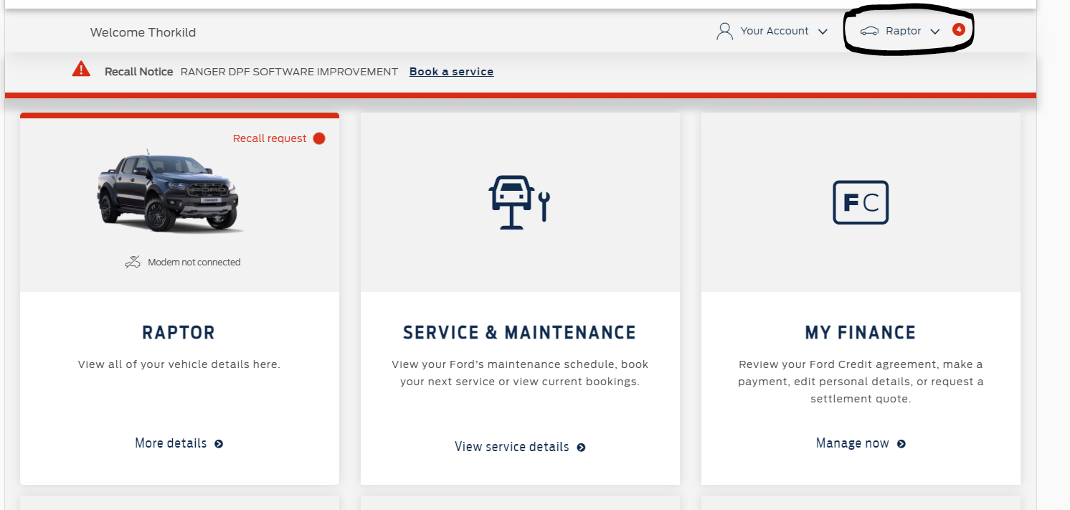

Once the Puma is selected, you’ll either see the below if you selected the Debug Prehandover QA Link: 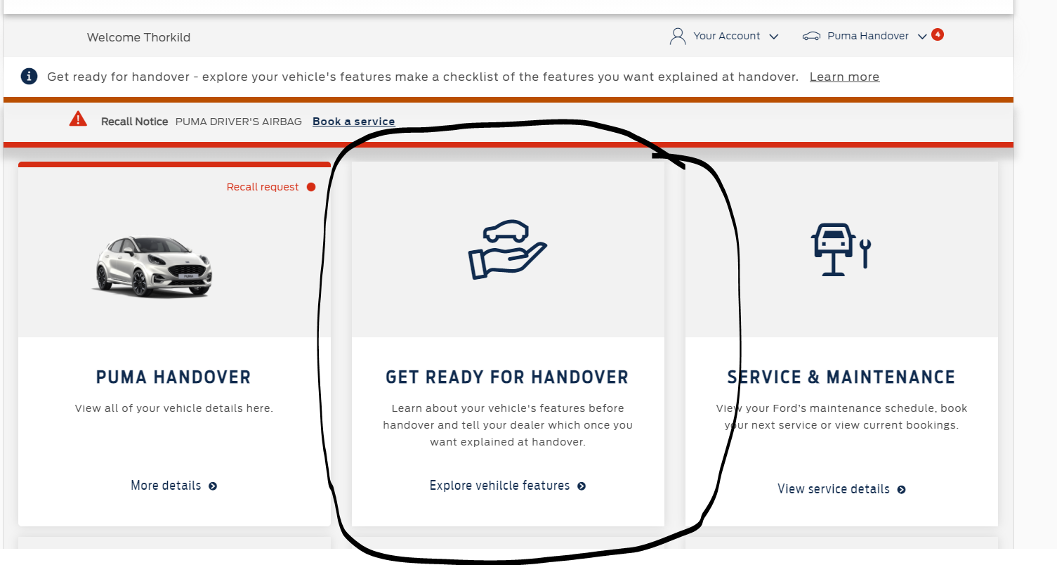

Or you’ll see the below if you used the Debug PostHandover QA Link: 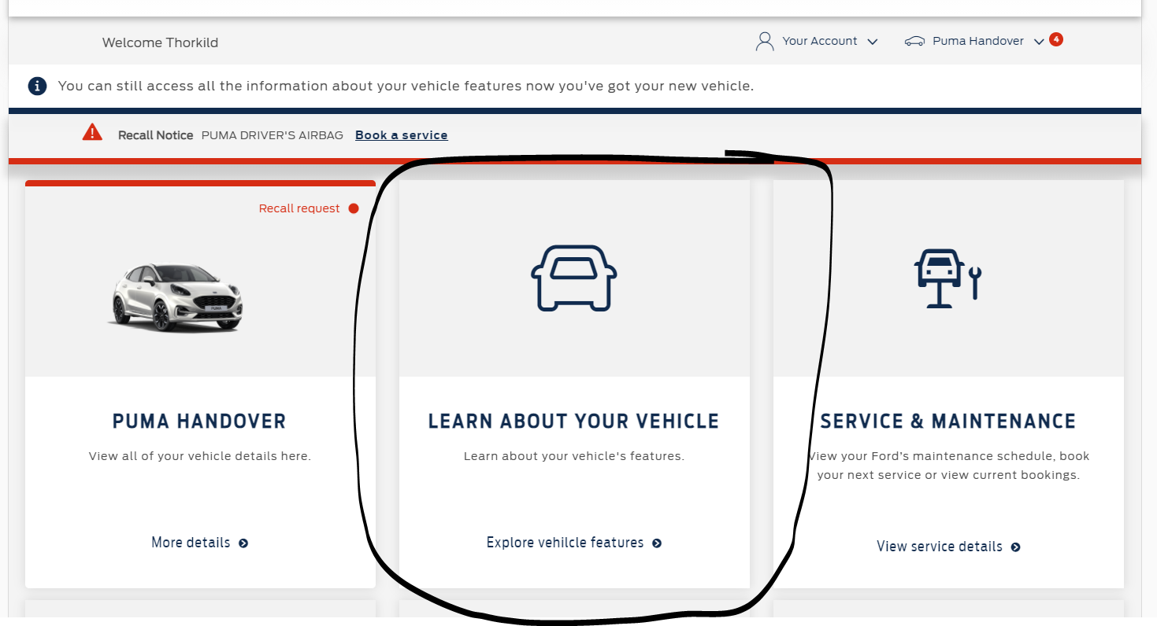

If both these work, we’re good to go. The first test is successful.  
  
Next we have the other method of testing. Close down your incognito browser and start up a new Incognito browser. Open the Phase 2 QA Link. You’ll have to log in most likely or potentially already be on the dashboard. Once you’re on the dashboard. Do the same you did at that top to get to the Puma. If you used the Phase 2 QA Link, you shouldn’t see any changes. So the 2nd block should be the Service & Maintenance.

Now, you can copy the Intended Method QA Link into the same tab and run it. Or you can close everything down and start a new Incognito browser to test. If you go with the first option, you should still be on the Puma page but this time the PreHandover box should be showing, that’s the “Get Ready for Handover” screenshot. If you went with the latter option. You’ll have to login in again and select the Puma from the dropdown list before getting the same result.

This is where the test ends, there isn’t an easy way to change the date in order to see the post handover box.

**Browser:**   
All  
  
**Device:**   
All  
  
**Audience rules:**   
User’s who have the otho=true parameter in their URL.  
Or users who have previously seen the PreHandover box.

**QA Link:**

**Debug PreHandover:** [**https://www.ford.co.uk/dashboard?at_preview_token=qAtDF9gpb0sj5pxEDcfQ-Q&at_preview_index=1&at_preview_listed_activities_only=true&targetDebug=1051&ho=pre**](https://www.ford.co.uk/dashboard?at_preview_token=qAtDF9gpb0sj5pxEDcfQ-Q&at_preview_index=1&at_preview_listed_activities_only=true&targetDebug=1051&ho=pre)

**Debug PostHandover:** [**https://www.ford.co.uk/dashboard?at_preview_token=qAtDF9gpb0sj5pxEDcfQ-Q&at_preview_index=1&at_preview_listed_activities_only=true&targetDebug=1051&ho=post**](https://www.ford.co.uk/dashboard?at_preview_token=qAtDF9gpb0sj5pxEDcfQ-Q&at_preview_index=1&at_preview_listed_activities_only=true&targetDebug=1051&ho=post)

**Extra QA Links:**

**Intended Method:** [**https://www.ford.co.uk/dashboard?at_preview_token=qAtDF9gpb0sj5pxEDcfQ-Q&at_preview_index=1&at_preview_listed_activities_only=true&otho=true**](https://www.ford.co.uk/dashboard?at_preview_token=qAtDF9gpb0sj5pxEDcfQ-Q&at_preview_index=1&at_preview_listed_activities_only=true&otho=true) **~ Runs PreHandover Code when on Puma page.**

**Phase 2:** [**https://www.ford.co.uk/dashboard?at_preview_token=qAtDF9gpb0sj5pxEDcfQ-Q&at_preview_index=1&at_preview_listed_activities_only=true**](https://www.ford.co.uk/dashboard?at_preview_token=qAtDF9gpb0sj5pxEDcfQ-Q&at_preview_index=1&at_preview_listed_activities_only=true) **~ You have already done the above link, this link will run PreHandover until it's been 14 days, in which case PostHandover code will run when on Puma.**